**PIZZAHUB**

**Documentation Design**

**Version 1.0**



Group Id: S25PROJECT31CA4

Supervisor Name: Muhammad Hashir Khan

**Revision History**

|  |  |  |  |
| --- | --- | --- | --- |
| **Date (dd/mm/yyyy)** | **Version** | **Description** | **Author** |
| 24/07/2025 | 1.0 | This design document provides detailed descriptions and diagrams, including ERD, sequence diagrams, architecture design, class diagrams, database design, interface design, and test cases, to serve as a comprehensive blueprint for developing the online mega store web application. It ensures that all functional and non-functional requirements are clearly addressed, enabling seamless communication between stakeholders and the development team. The document also guides the implementation phase by offering a well-structured foundation for coding, testing, and deployment. | Bc220200967 |

**Table of Content**

Introduction of Design Document:- 5

1. Overview 5

2. Entity Relationship Diagram (ERD) 5

3. Sequence Diagrams 5

4. System Architecture Diagram 5

5. Class Diagram 5

6. Database Design 6

7. User Interface Design 6

8. Test Cases 6

9. Importance of the Design Phase 6

Entity Relationship Diagram (ERD) 7

Sequence Diagrams:- 8

Architecture Design Diagram:- 22

Class Diagram:- 23

Database Design 24

Interface Designs- 26

**HomePage:-** 26

**Our Menu :-** 26

**Register With Us:-** 28

**Login:-** 29

**Why Choose Us:-** 30

Test Cases 31

TC-01- Register 31

TC-02 - Login 31

TC-03 – Search Product 31

TC-04 - View Product &Categories 32

TC-05 - Add to Cart 32

TC-06 - Place Order 32

TC-07 - Track Order 33

TC-08 - Give Feedback 33

TC-09 - Manage Products 34

TC-10- Manage Orders 34

TC-11 - Apply Discounts 34

TC-172- Generate Invoices 35

TC-183- Manage Customers 35

TC-14 - Logout 35

# Introduction of Design Document:-

## 1. Overview

This document presents the design strategy and architecture for the pizzahub application. It includes diagrams and detailed descriptions that collectively explain the structural and behavioral components of the system. This blueprint is meant to support the development process by documenting all system components clearly.

## 2. Entity Relationship Diagram (ERD)

The ERD visually represents the data entities, their attributes, and the relationships among them. It includes:  
- Entities: Data objects like Users, Furniture, Orders.  
- Relationships: Logical associations between entities.  
- Attributes: Properties of entities, such as User_ID, Email.  
This diagram helps visualize the backend structure of the system and ensures efficient data organization.

## 3. Sequence Diagrams

Sequence diagrams illustrate object interactions in a time sequence. Key elements include:  
- Objects: Instances involved in interaction.  
- Messages: Arrows showing communication between objects.  
- Lifelines & Activation/Deactivation: Visual indicators of object states and activity duration.  
- Alternative flows & Conditions: Represent decision points and branching scenarios.  
Each use case includes a sequence diagram to clarify the dynamic workflow of the system.

## 4. System Architecture Diagram

This layered architecture outlines the distribution of functionality across components:  
- Layers: Presentation, Business Logic, and Data Access.  
- Components: UI, API Controllers, Services, Database.  
- Interactions: How components communicate across tiers.  
The architecture provides an overall structural view and guides development, testing, and deployment.

## 5. Class Diagram

Class diagrams describe the system’s static structure. Elements include:  
- Classes: Templates like User, Admin, Order.  
- Attributes/Methods: Internal properties and functions of each class.  
- Relationships: Including inheritance (Admin inherits User), aggregation, composition, and associations.  
- Multiplicity, Interfaces, and Dependencies: Enhances OOP clarity and extensibility.

## 6. Database Design

The database schema is organized using normalized tables with defined relationships:  
- Tables: Structures storing information (Users, Furniture, Orders).  
- Fields: Representing data columns within tables.  
- Foreign Keys: Ensuring relational integrity between tables.  
The design supports scalability, performance, and ease of data retrieval.

## 7. User Interface Design

This section showcases the visual design of the system:  
- Screens: Sample screenshots of key interfaces.  
- Layouts: Page structure and component organization.  
- Accessibility: Compliance with accessibility standards.  
- Responsive Design: Adjusts across devices using media queries.  
- Rationale: Reasoning behind layout and UX choices.

## 8. Test Cases

To ensure robust system performance, test documentation includes:  
- Scenarios: Contexts for testing features.  
- Steps: Detailed action flows for testing.  
- Expected Results: Success criteria per test.  
Testing validates compliance with functional requirements.

# 9. Importance of the Design Phase

The design phase plays a pivotal role:  
- Shared Understanding: Clear communication between stakeholders.  
- Risk Identification: Early visibility of problems and inefficiencies.  
- Quality Control: Sets the basis for testing and requirement validation.  
- Scalability & Maintenance: Enables long-term flexibility and efficiency.  
In conclusion, this document enables successful implementation of the pizzahub application by offering well-documented and organized guidance.

# Entity Relationship Diagram (ERD)

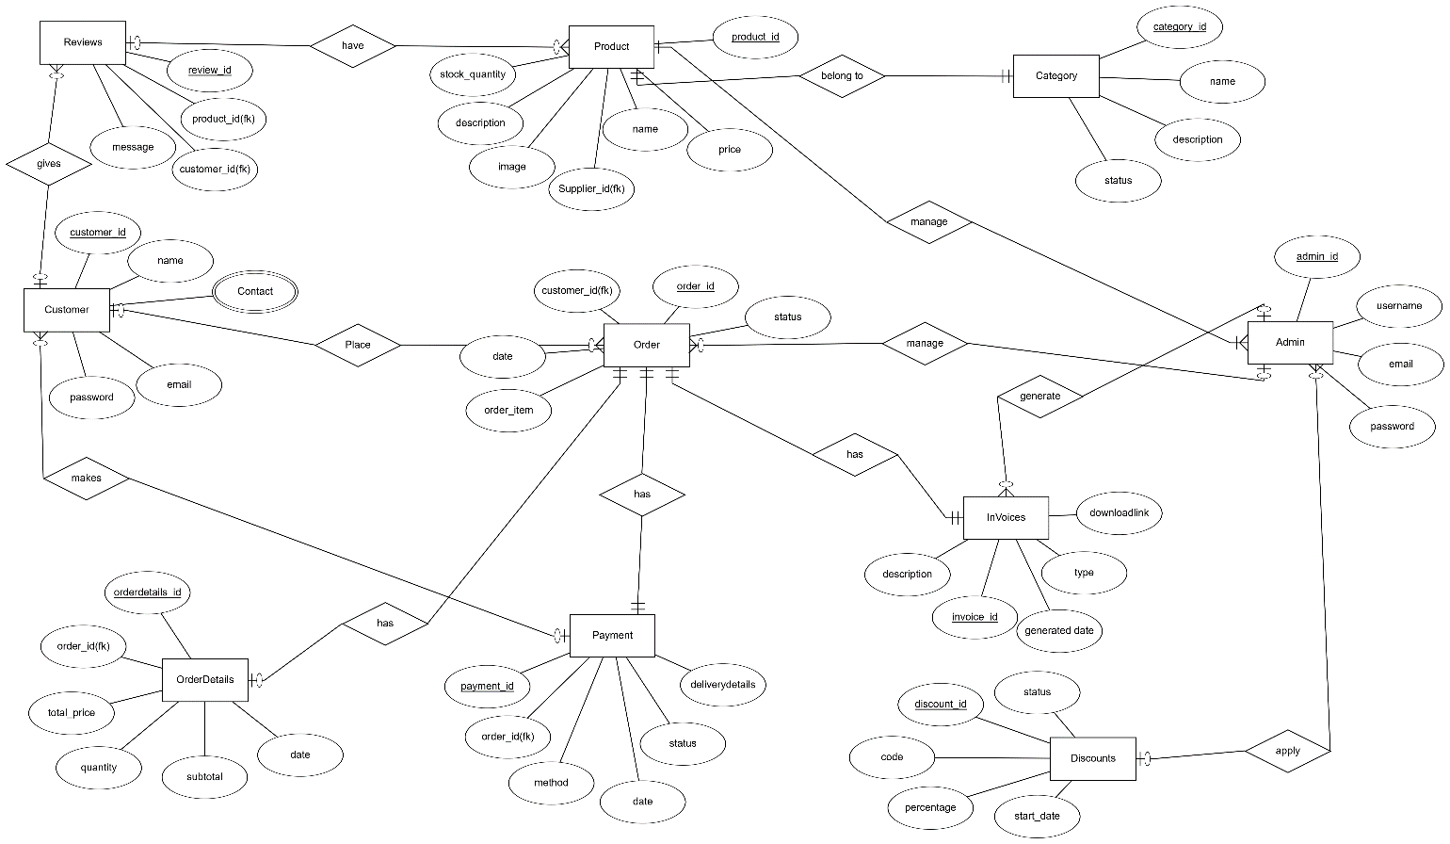

Diagram 1

# Sequence Diagrams:-

1. **Register**

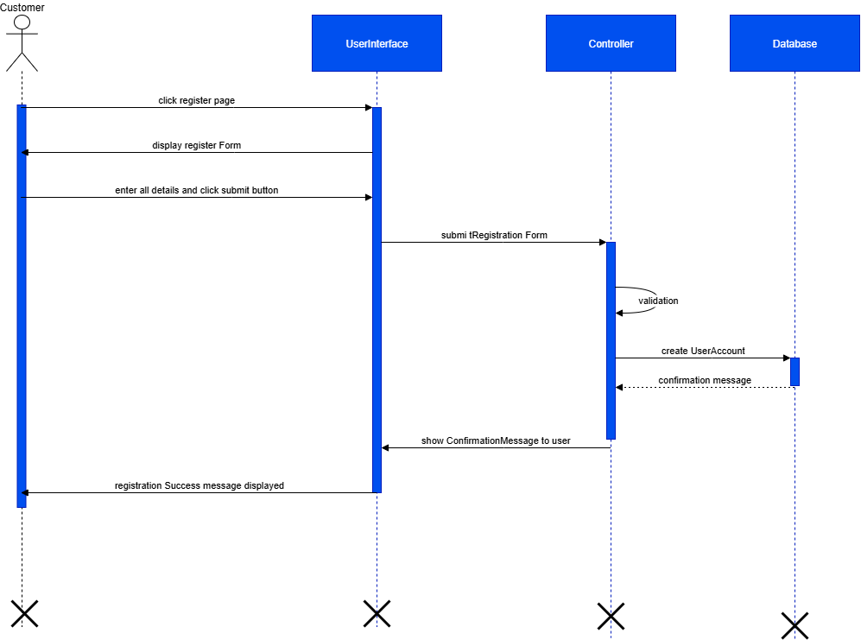

Diagram 2

1. **Login**

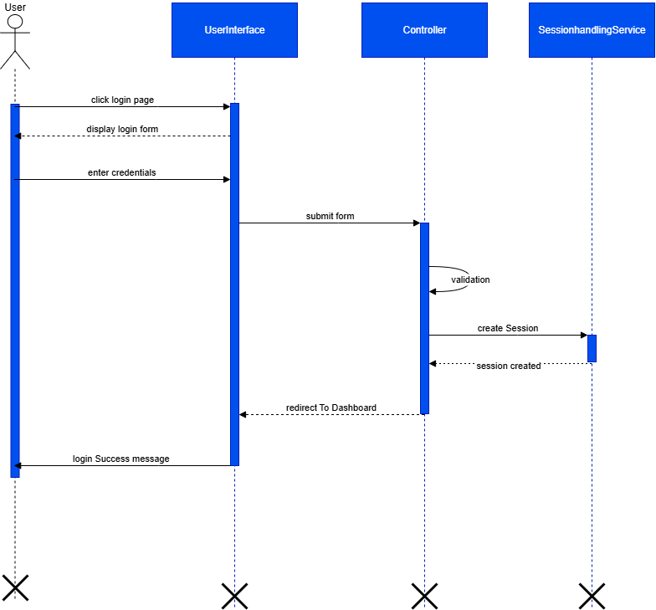

Diagram 3

1. **Search Product**

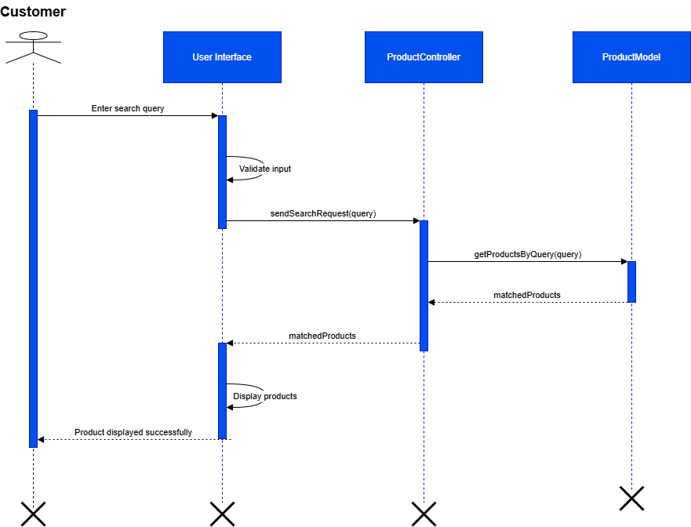

Diagram 4

1. **View Product & Categories**

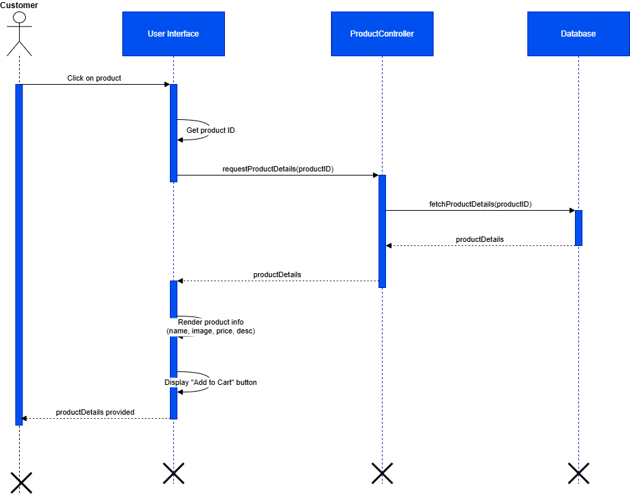

Diagram 5

1. **Add to Cart**

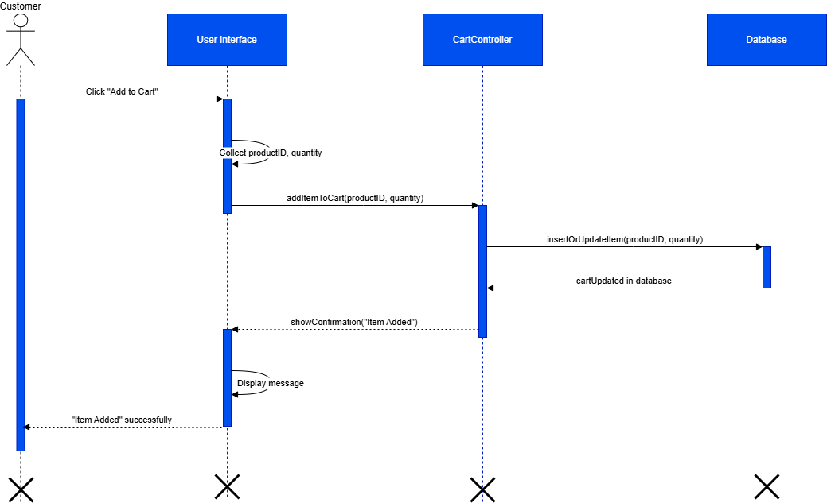

Diagram 6

1. **Place Order**

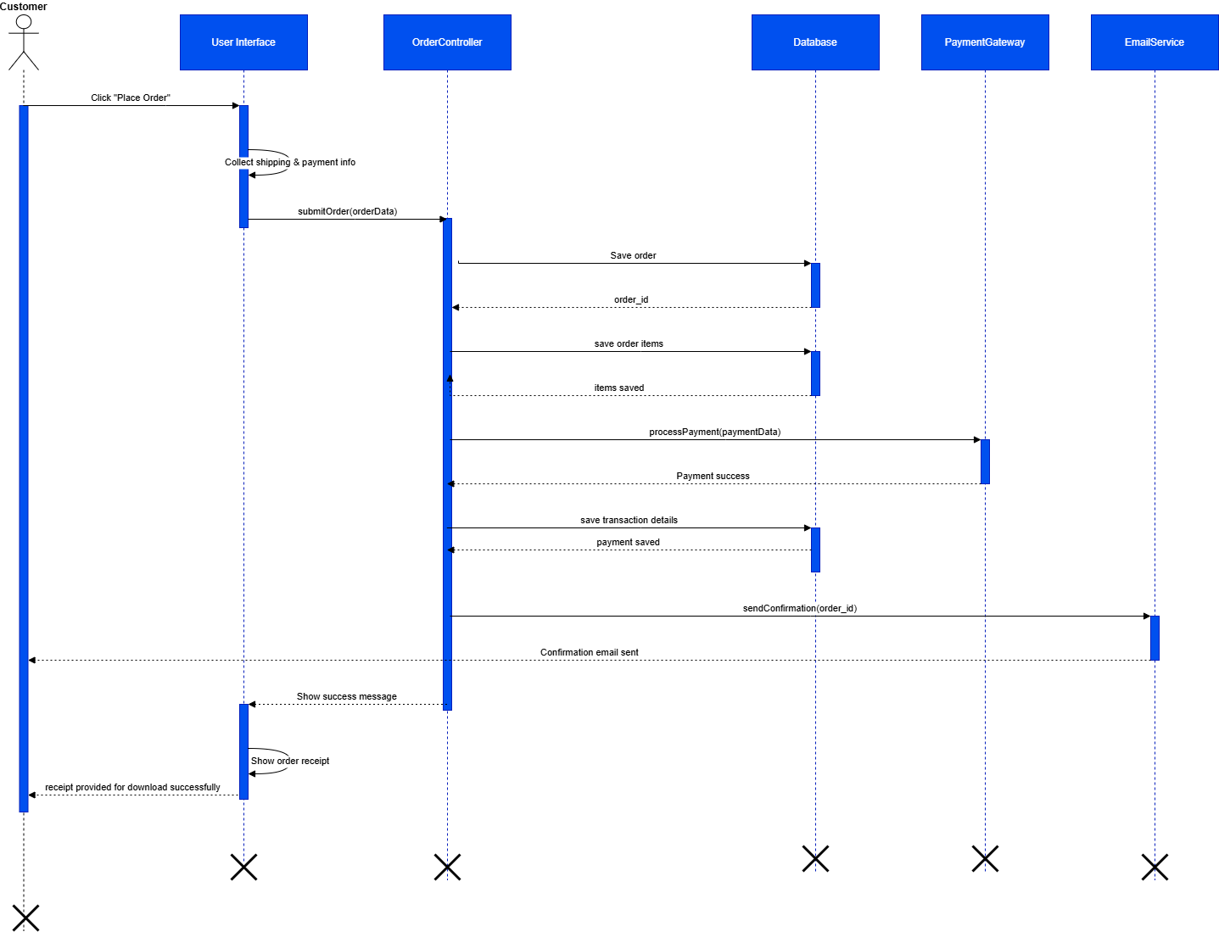

Diagram 7

1. **Track Order**

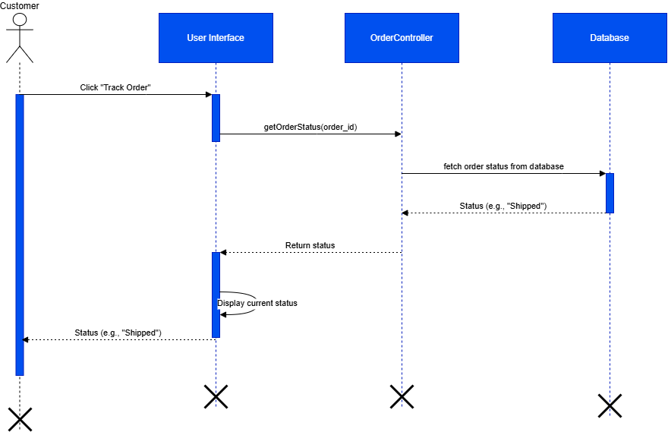

Diagram 8

1. **Give Feedback**

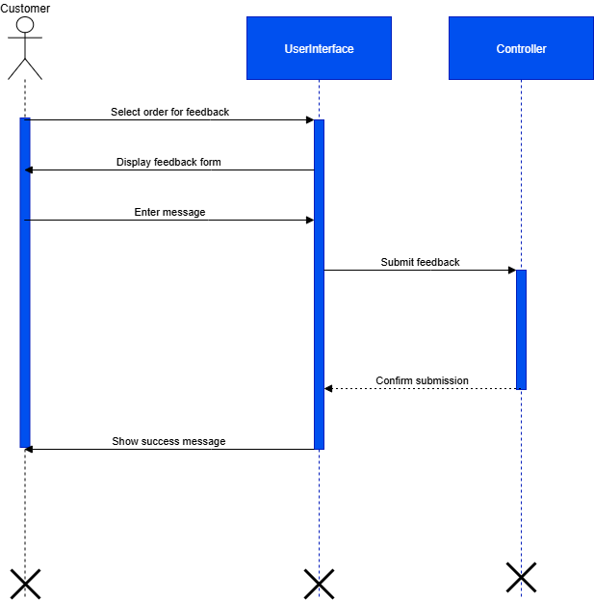

Diagram 9

1. **Manage Products**

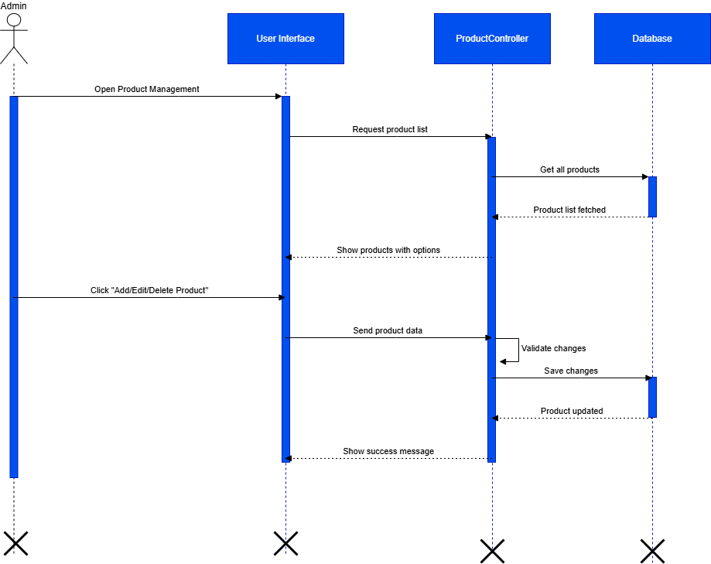

Diagram 10

1. **Manage Orders**

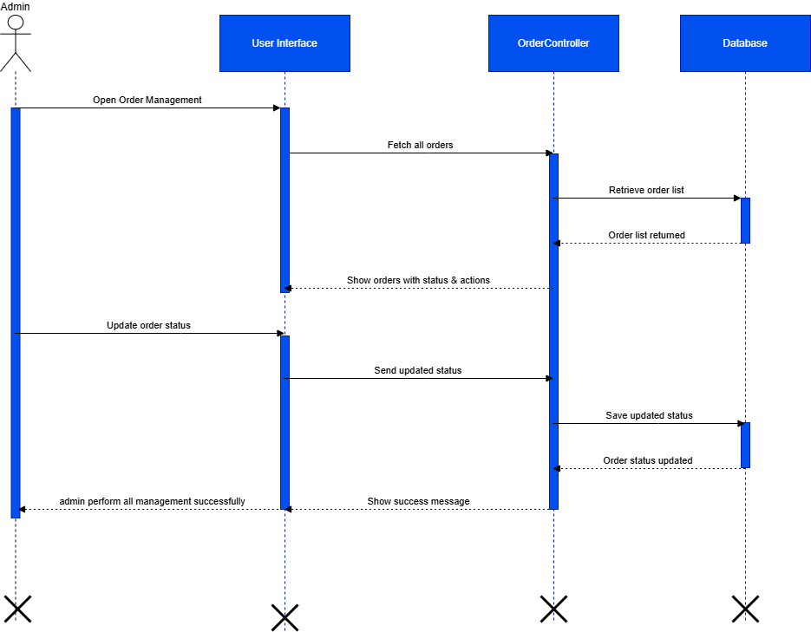

Diagram 11

1. **Apply Discounts**

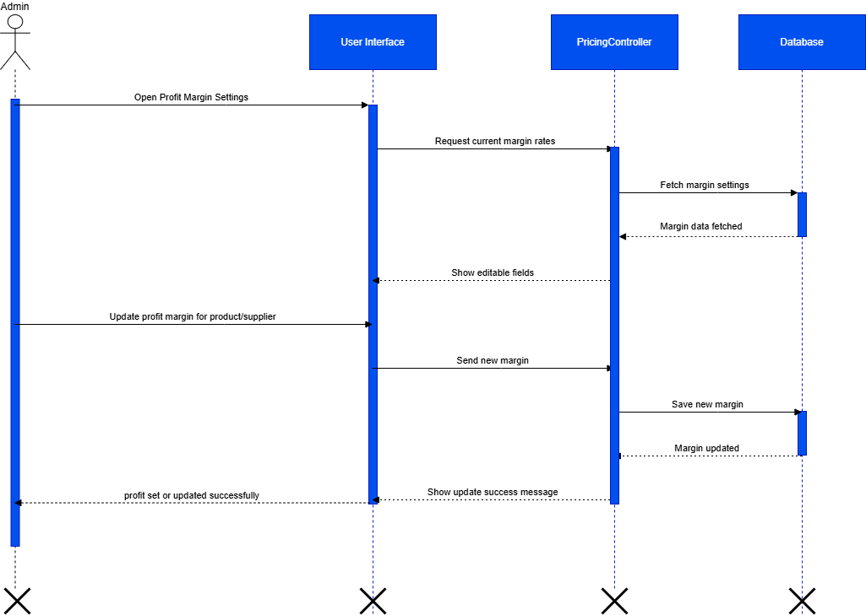

Diagram 12

1. **Generate Invoices**

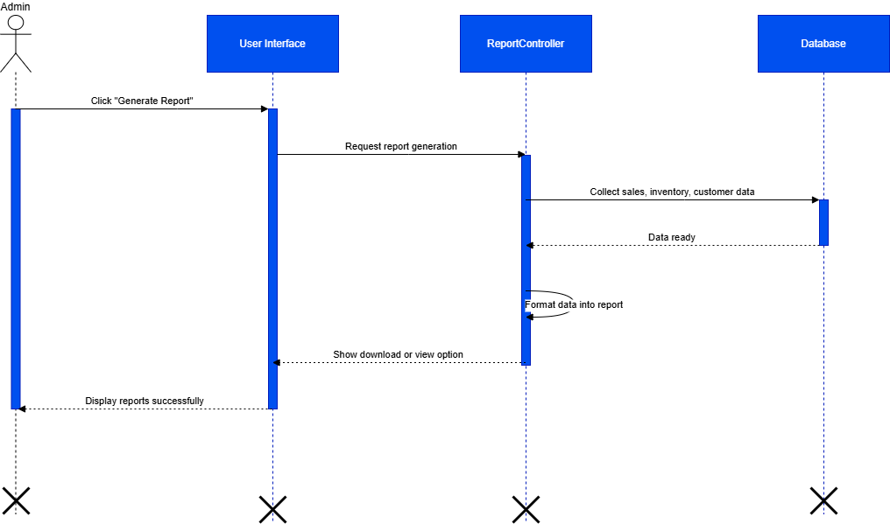

Diagram 13

1. **Manage Customers**

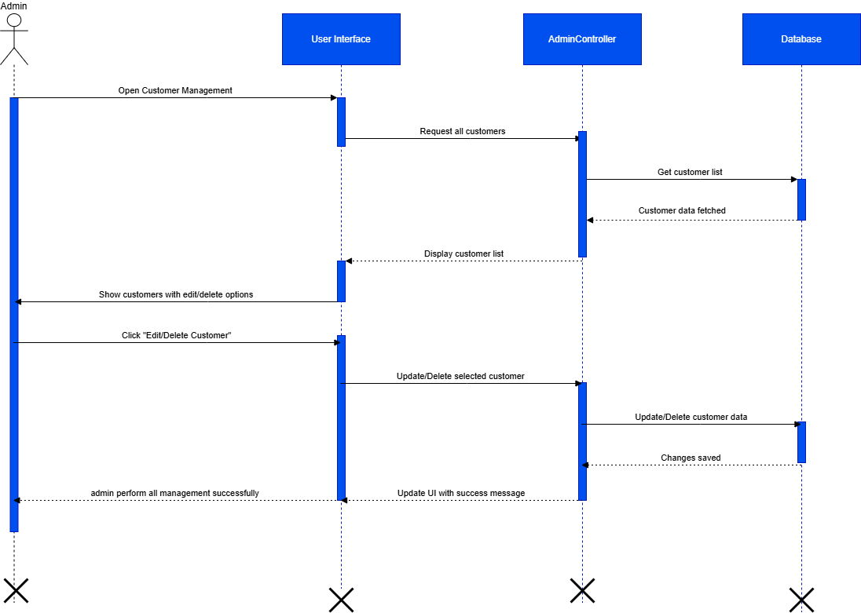

Diagram 14

1. **Logout**

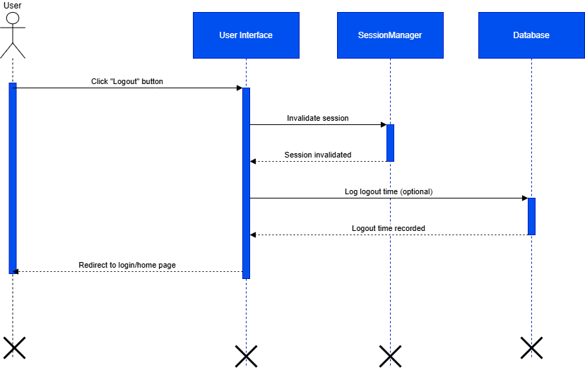

Diagram 15

# Architecture Design Diagram:-

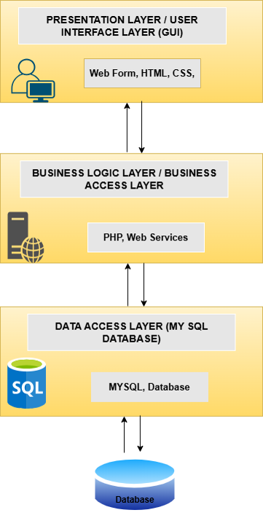

Diagram 16

# Class Diagram:-

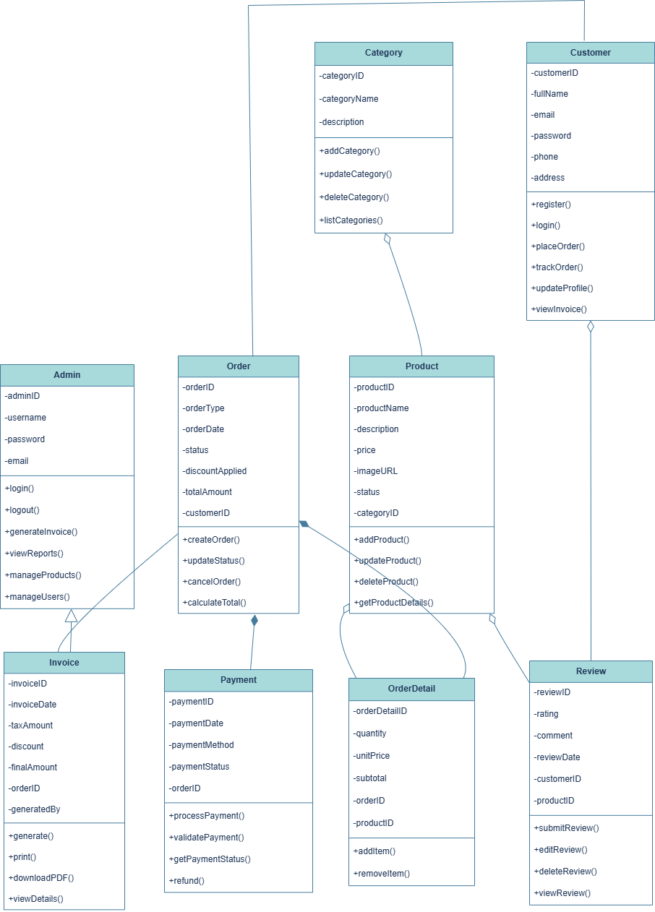

Diagram 17

# Database Design

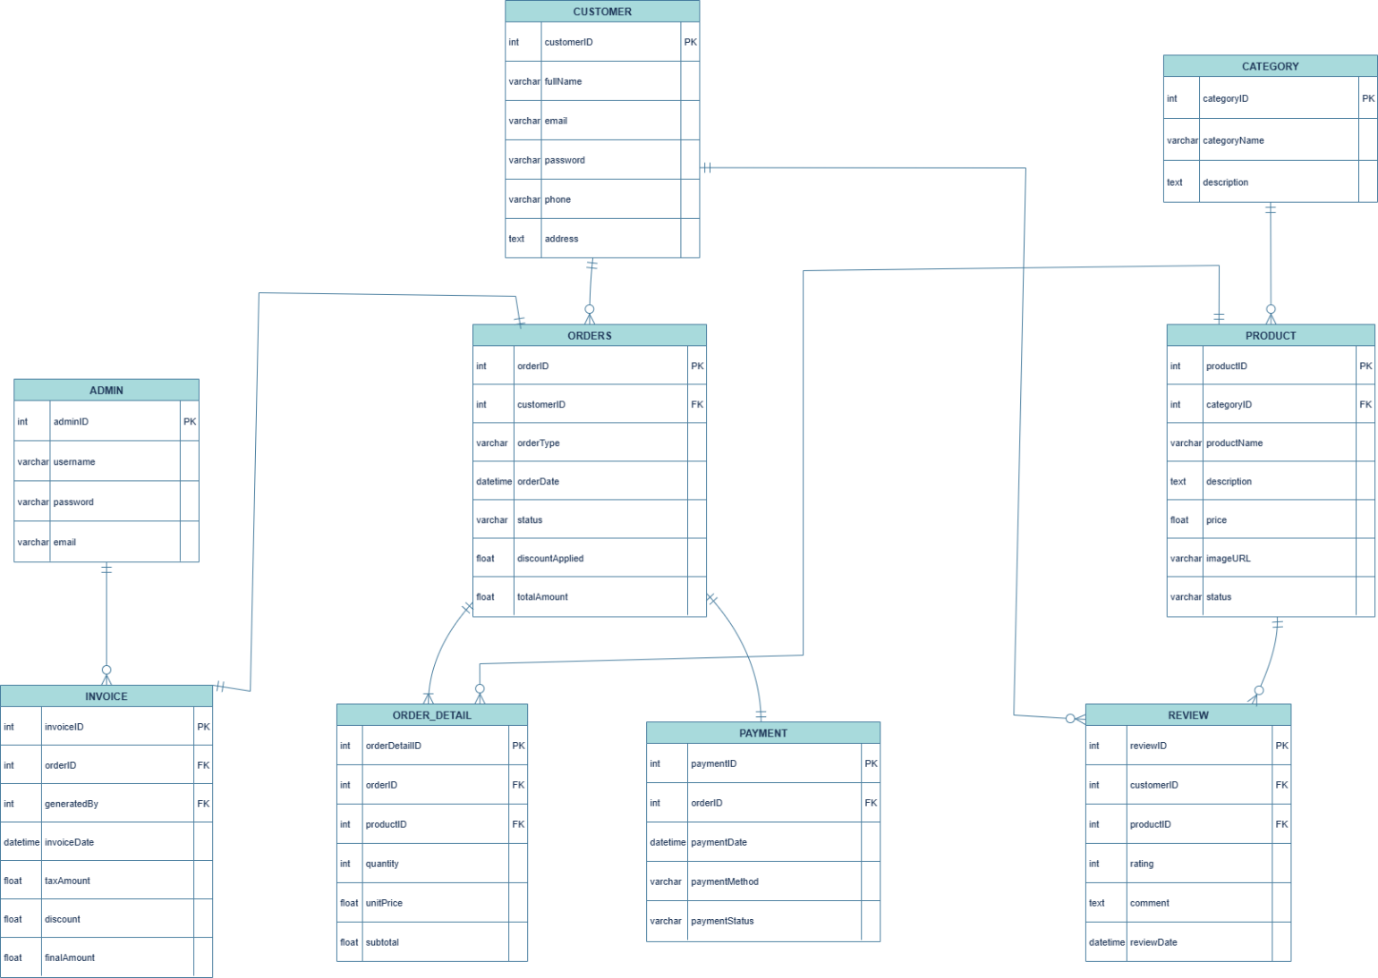

Diagram 18

## Interface Designs-

### **HomePage:-**



### **Our Menu :-**

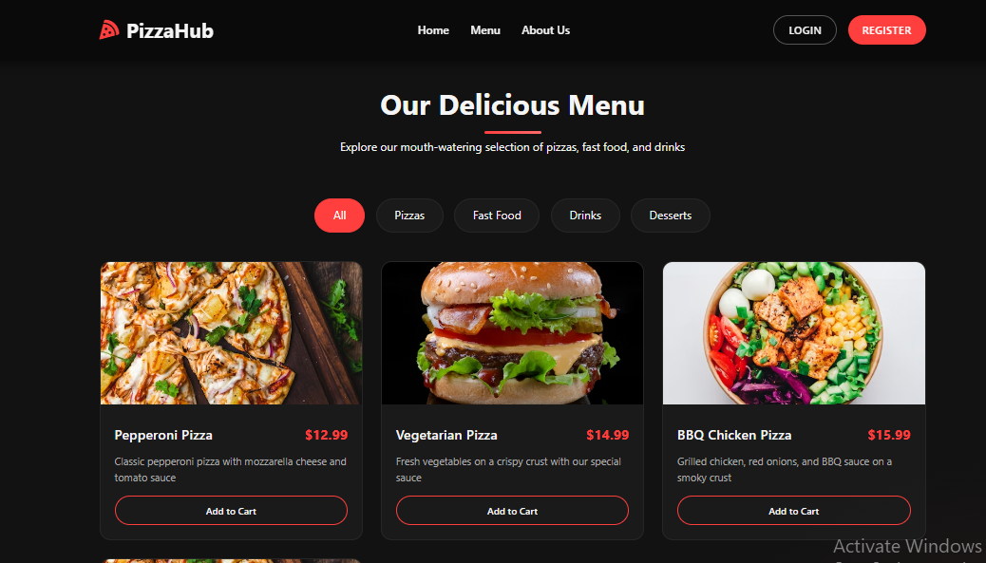

### **Register With Us:-**

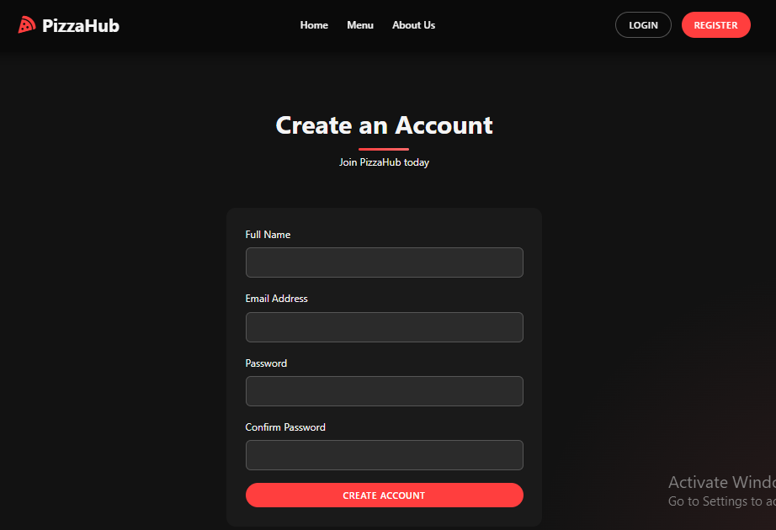

### **Login:-**

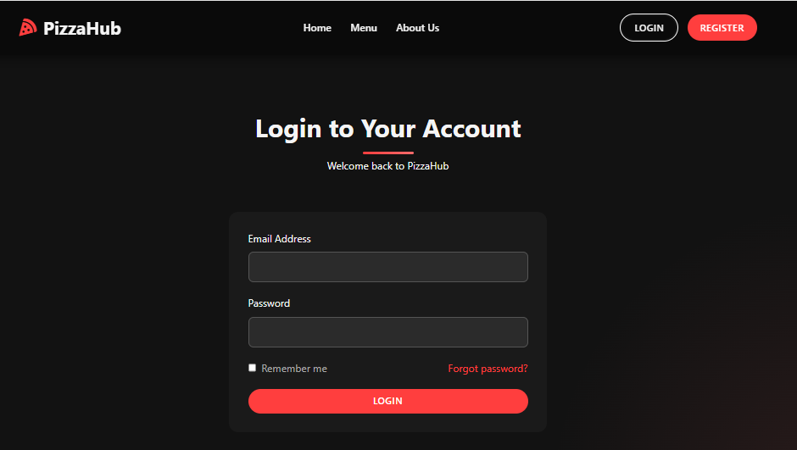

### **Why Choose Us:-**

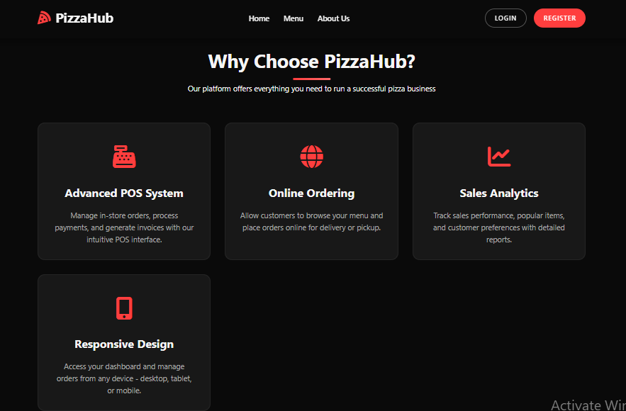

## Test Cases

# TC-01- Register

|  |  |  |  |  |  |  |  |
| --- | --- | --- | --- | --- | --- | --- | --- |
| Test Case ID | Test Case Name | Description | Test Steps | Test Data | Expected Results | Test Result | Tested By |
| TC-01 | Register | Test successful registration of a user | 1. Go to respective page 2. Fill required data 3. Submit and verify outcome | Valid inputs for the use case | Register should be performed successfully | Pass | Bc220200967 |

# TC-02 - Login

|  |  |  |  |  |  |  |  |
| --- | --- | --- | --- | --- | --- | --- | --- |
| Test Case ID | Test Case Name | Description | Test Steps | Test Data | Expected Results | Test Result | Tested By |
| TC-02 | Login | Test successful login of a user | 1. Go to respective page 2. Fill required data 3. Submit and verify outcome | Valid inputs for the use case | Login should be performed successfully | Pass | Bc220200967 |

# TC-03 – Search Product

|  |  |  |  |  |  |  |  |
| --- | --- | --- | --- | --- | --- | --- | --- |
| Test Case ID | Test Case Name | Description | Test Steps | Test Data | Expected Results | Test Result | Tested By |
| TC-03 | Search product | Test browsing available menu items | 1. Go to respective page 2. Fill required data 3. Submit and verify outcome | Valid inputs for the use case | Browse Menu should be performed successfully | Pass | Bc220200967 |

# TC-04 - View Product &Categories

|  |  |  |  |  |  |  |  |
| --- | --- | --- | --- | --- | --- | --- | --- |
| Test Case ID | Test Case Name | Description | Test Steps | Test Data | Expected Results | Test Result | Tested By |
| TC-04 | View the product with Categories | Test viewing menu by category | 1. Go to respective page 2. Fill required data 3. Submit and verify outcome | Valid inputs for the use case | View the Menu with Categories should be performed successfully | Pass | Bc220200967 |

# TC-05 - Add to Cart

|  |  |  |  |  |  |  |  |
| --- | --- | --- | --- | --- | --- | --- | --- |
| Test Case ID | Test Case Name | Description | Test Steps | Test Data | Expected Results | Test Result | Tested By |
| TC-05 | Add to Cart | Test adding an item to the shopping cart | 1. Go to respective page 2. Fill required data 3. Submit and verify outcome | Valid inputs for the use case | Add to Cart should be performed successfully | Pass | Bc220200967 |

# TC-06 - Place Order

|  |  |  |  |  |  |  |  |
| --- | --- | --- | --- | --- | --- | --- | --- |
| Test Case ID | Test Case Name | Description | Test Steps | Test Data | Expected Results | Test Result | Tested By |
| TC-06 | Place Order | Test placing an order | 1. Go to respective page 2. Fill required data 3. Submit and verify outcome | Valid inputs for the use case | Place Order should be performed successfully | Pass | Bc220200967 |

# TC-07 - Track Order

|  |  |  |  |  |  |  |  |
| --- | --- | --- | --- | --- | --- | --- | --- |
| Test Case ID | Test Case Name | Description | Test Steps | Test Data | Expected Results | Test Result | Tested By |
| TC-07 | Track Order | Test tracking the current order status | 1. Go to respective page 2. Fill required data 3. Submit and verify outcome | Valid inputs for the use case | Track Order should be performed successfully | Pass | Bc220200967 |

# TC-08 - Give Feedback

|  |  |  |  |  |  |  |  |
| --- | --- | --- | --- | --- | --- | --- | --- |
| Test Case ID | Test Case Name | Description | Test Steps | Test Data | Expected Results | Test Result | Tested By |
| TC-08 | Write Feedback | Test writing feedback for an order | 1. Go to respective page 2. Fill required data 3. Submit and verify outcome | Valid inputs for the use case | Write Feedback should be performed successfully | Pass | Bc220200967 |

# TC-09 - Manage Products

|  |  |  |  |  |  |  |  |
| --- | --- | --- | --- | --- | --- | --- | --- |
| Test Case ID | Test Case Name | Description | Test Steps | Test Data | Expected Results | Test Result | Tested By |
| TC-09 | Manage Products | Test adding/updating/deleting products | 1. Go to respective page 2. Fill required data 3. Submit and verify outcome | Valid inputs for the use case | Manage Products should be performed successfully | Pass | Bc220200967 |

# TC-10- Manage Orders

|  |  |  |  |  |  |  |  |
| --- | --- | --- | --- | --- | --- | --- | --- |
| Test Case ID | Test Case Name | Description | Test Steps | Test Data | Expected Results | Test Result | Tested By |
| TC-10 | Manage Orders | Test managing customer orders | 1. Go to respective page 2. Fill required data 3. Submit and verify outcome | Valid inputs for the use case | Manage Orders should be performed successfully | Pass | Bc220200967 |

# TC-11 - Apply Discounts

|  |  |  |  |  |  |  |  |
| --- | --- | --- | --- | --- | --- | --- | --- |
| Test Case ID | Test Case Name | Description | Test Steps | Test Data | Expected Results | Test Result | Tested By |
| TC-11 | Apply Discounts | Test applying discounts to orders | 1. Go to respective page 2. Fill required data 3. Submit and verify outcome | Valid inputs for the use case | Apply Discounts should be performed successfully | Pass | Bc220200967 |

# TC-172- Generate Invoices

|  |  |  |  |  |  |  |  |
| --- | --- | --- | --- | --- | --- | --- | --- |
| Test Case ID | Test Case Name | Description | Test Steps | Test Data | Expected Results | Test Result | Tested By |
| TC-12 | Generate Invoices | Test generating invoices after order | 1. Go to respective page 2. Fill required data 3. Submit and verify outcome | Valid inputs for the use case | Generate Invoices should be performed successfully | Pass | Bc220200967 |

# TC-183- Manage Customers

|  |  |  |  |  |  |  |  |
| --- | --- | --- | --- | --- | --- | --- | --- |
| Test Case ID | Test Case Name | Description | Test Steps | Test Data | Expected Results | Test Result | Tested By |
| TC-13 | Manage Customers | Test managing registered customers | 1. Go to respective page 2. Fill required data 3. Submit and verify outcome | Valid inputs for the use case | Manage Customers should be performed successfully | Pass | Bc220200967 |

# TC-14 - Logout

|  |  |  |  |  |  |  |  |
| --- | --- | --- | --- | --- | --- | --- | --- |
| Test Case ID | Test Case Name | Description | Test Steps | Test Data | Expected Results | Test Result | Tested By |
| TC-14 | Logout | Test logging out of the system | 1. Go to respective page 2. Fill required data 3. Submit and verify outcome | Valid inputs for the use case | Logout should be performed successfully | Pass | Bc220200967 |